SqueakCards: Tools and Techniques

These materials are designed for classroom teachers who want to introduce Squeak to their students. All of the materials are freely available at www.squeakcmi.org. They are developed at the Office for Mathematics, Science, and Technology Education at the University of Illinois.

Squeak Card Student Handouts
- Each page is a student handout version of a SqueakCard lesson that is also an inter-active Squeak Project.
- Are print ready and can be printed in color or black and white.
- All four panels of the card print on one side of a piece of paper.
- Can be used in any order the teacher chooses.

kh
July 2007
SqueakCard Table of Contents

All Scripts Stop-Step-Go 3
Choose Language Menu 4
Forward and Turn 5
Forward By Tile 6
Get Halo Handles 7
Grab Me Reveal Me Menu 8

Grab Patch Tool 9
Halo of Handles 10
Hide and Show 11
Joystick Control 12
Motion Bounce 13
MouseStilDown in Script Run Menu 14

Paint Brush Sizes 15
Paint Bucket Tool 16
Paint Color Match Eye-dropper 17
Paint Colors Palette 18
Paint Ellipse Tool 19
Paint Polygon Tool 20

Paint Rectangle Tool 21
Paint Stamp Tool 22
Paint Palette Straight Line Tool 23
Pen Trails 24
Scale Factor 25
Simple and Detailed Watchers 26

Slider Control 27
Stamp Tile 28
Turn By Tile 29
X and Y Positions 30

All Scripts Stop-Step-Go

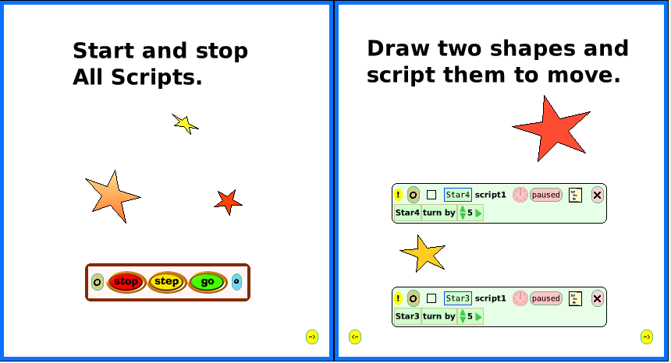
1 2

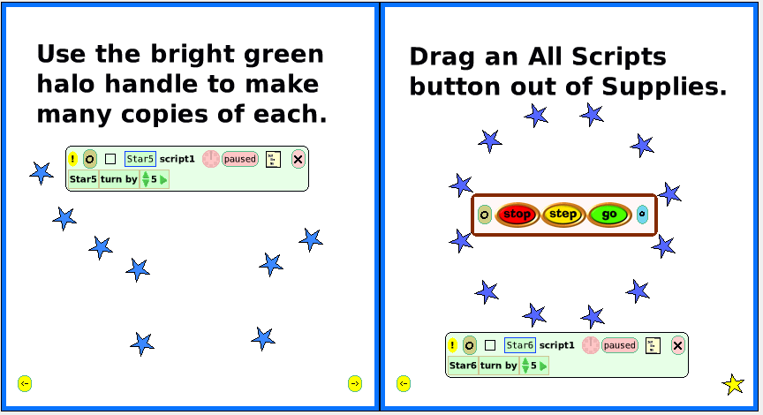
3 4

Choose Language Menu

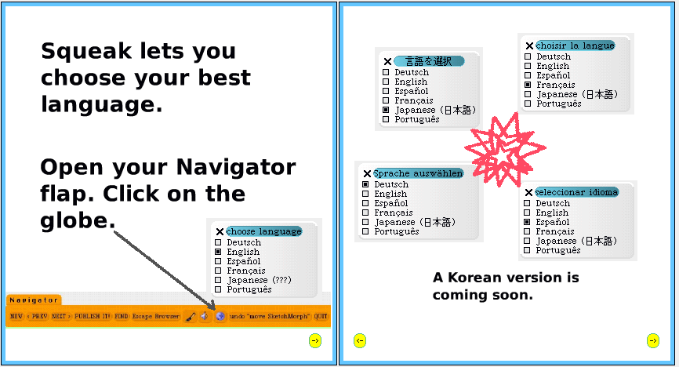
1 2

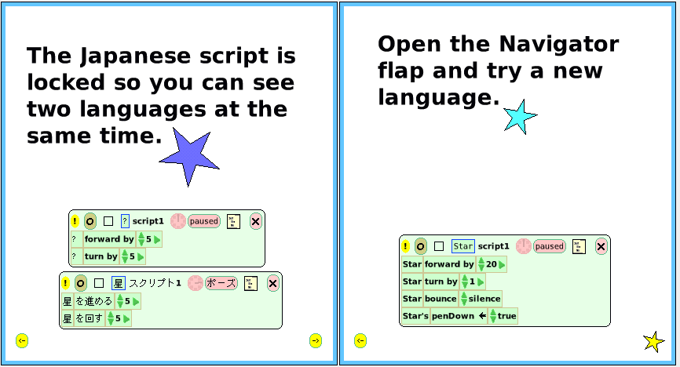
3 4

Forward and Turn

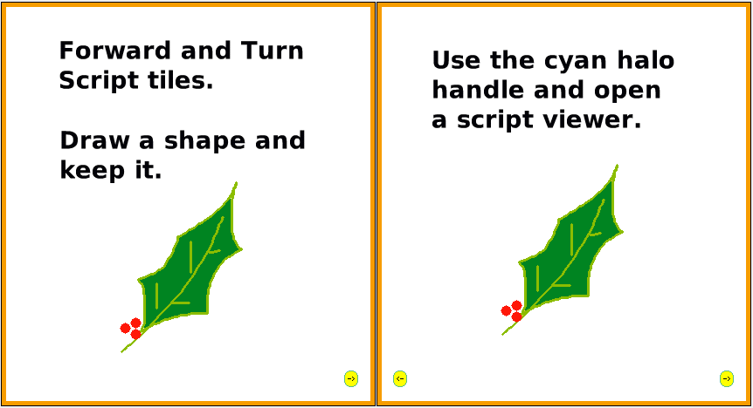
1 2

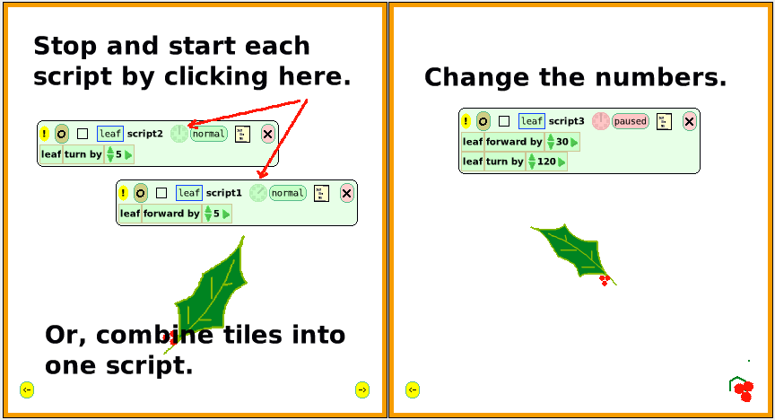
3 4

Forward By Tile

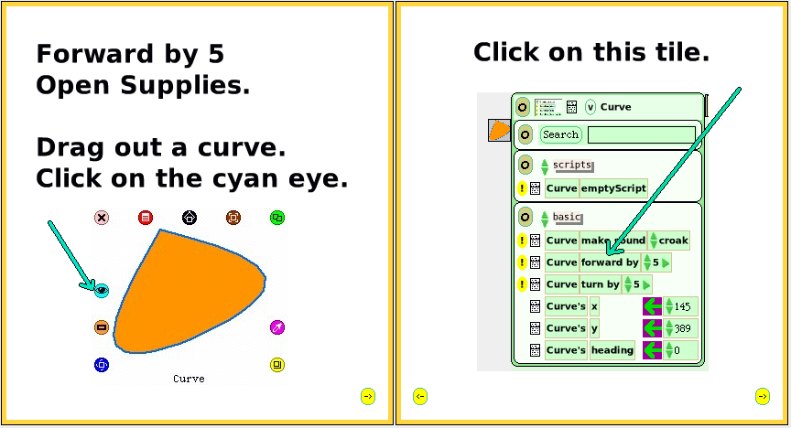
1 2

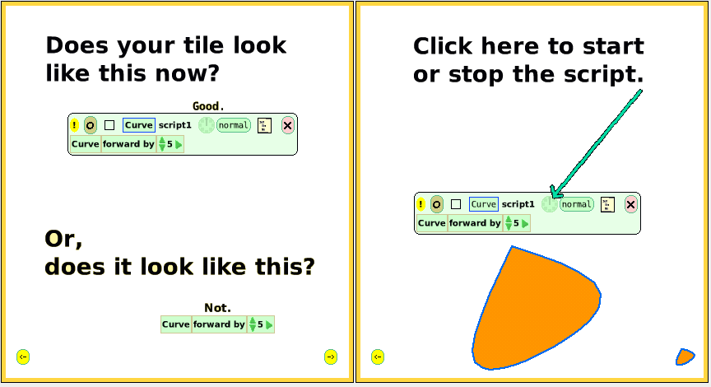
3 4
Get Halo Handles

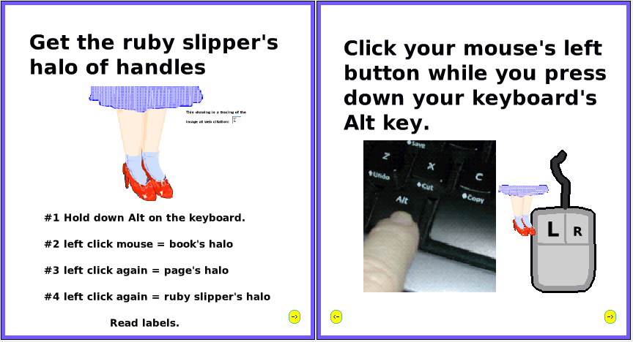
1 2

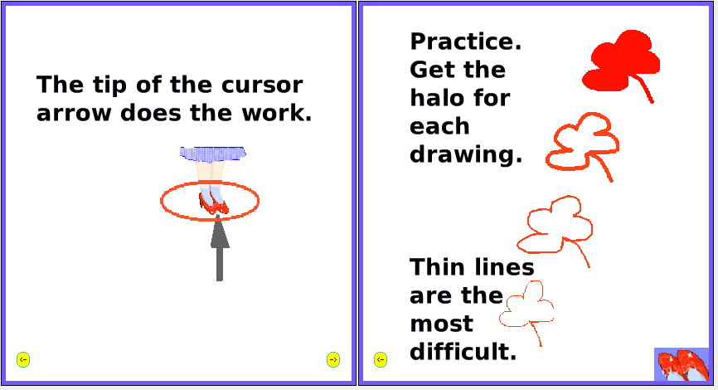
3 4

Grab Me Reveal Me Menu

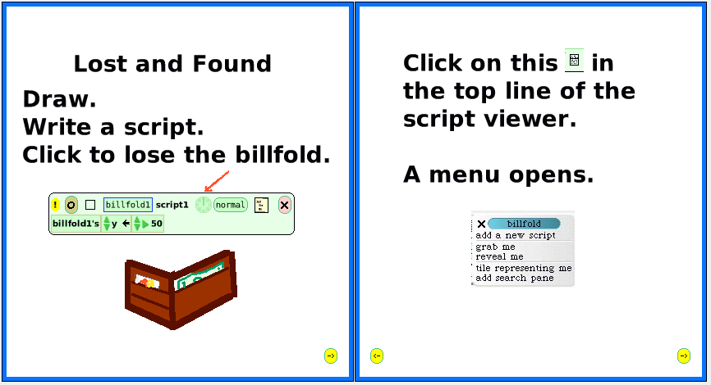
1 2

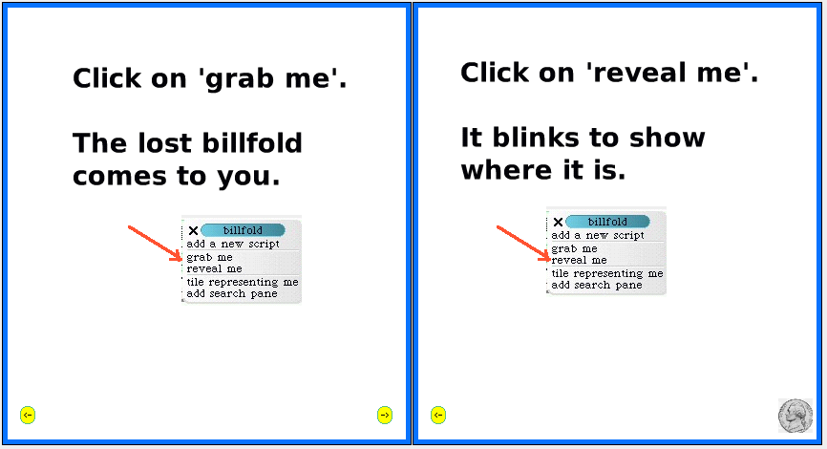
3 4
Grab Patch Tool

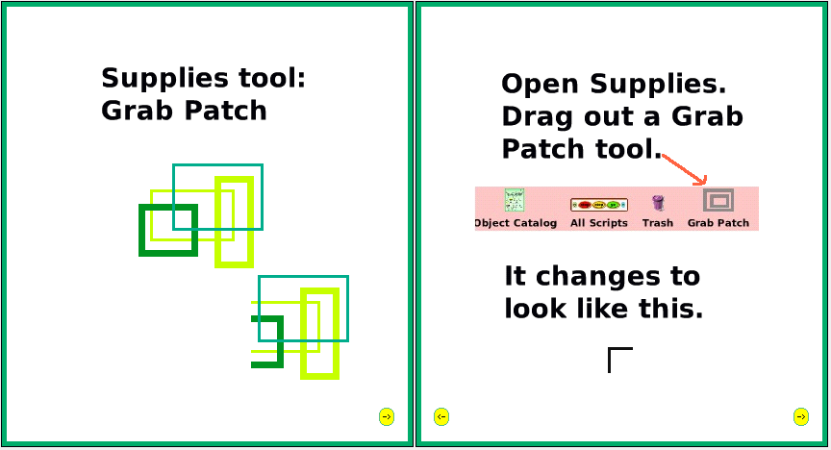
1 2

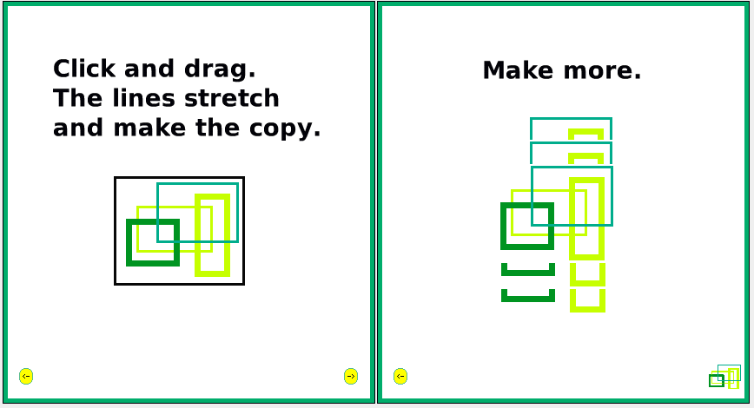
3 4

Halo of Handles Tools

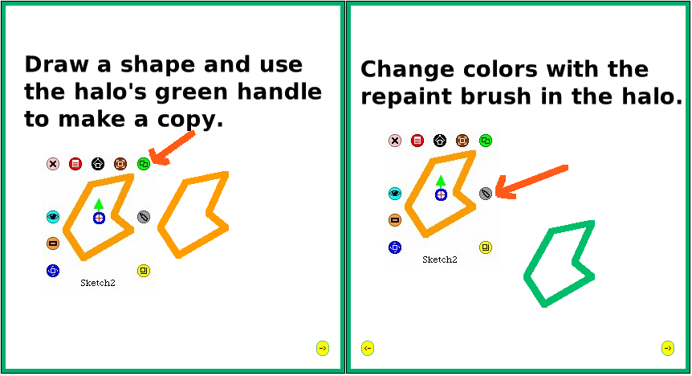
1 2

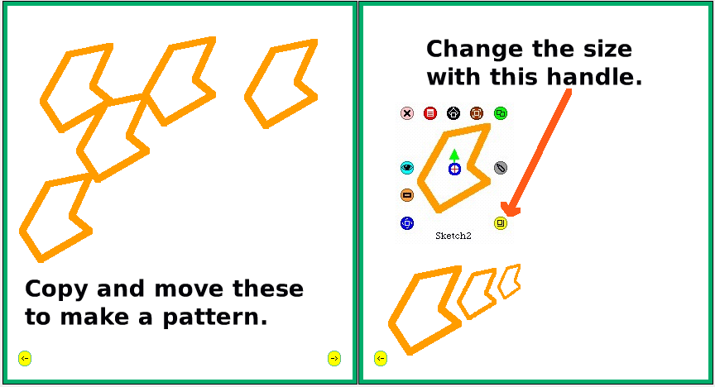
3 4
Hide and Show
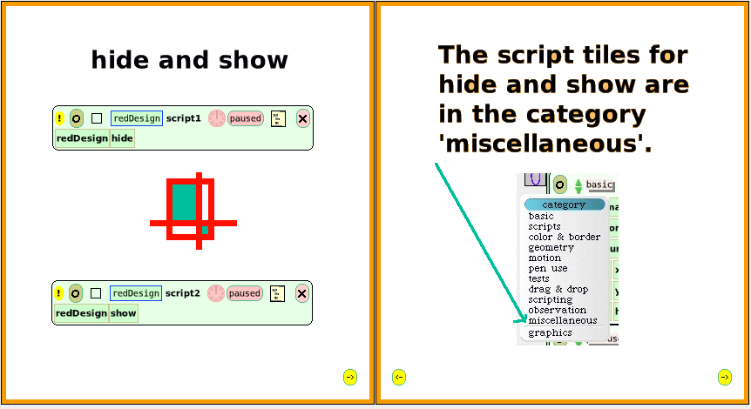
1 2

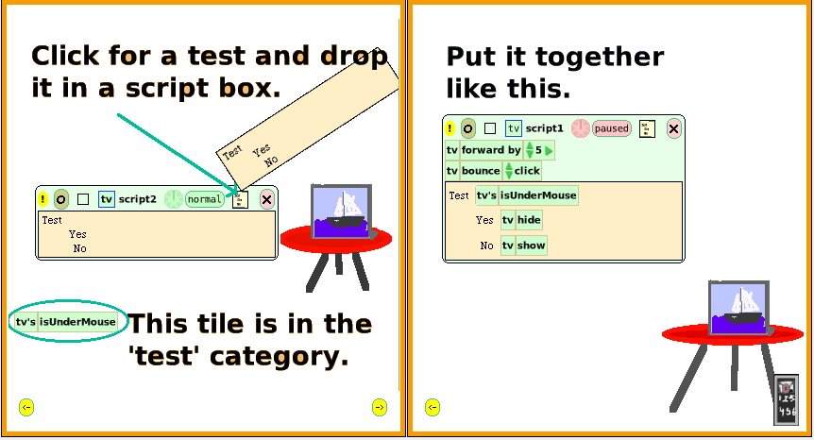
3 4

Joystick Control

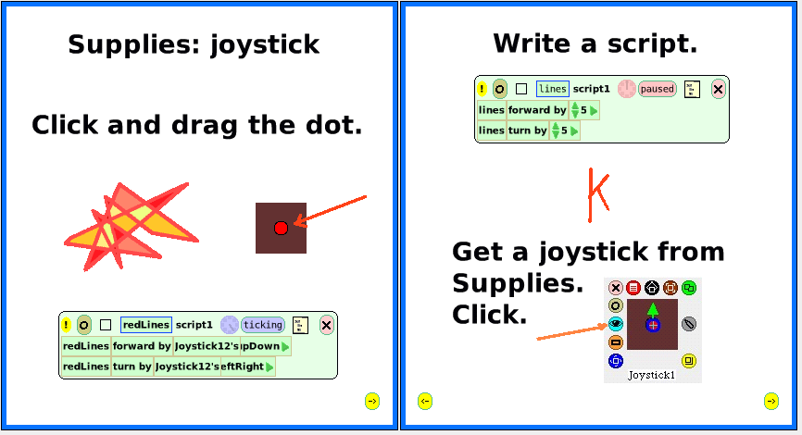
1 2

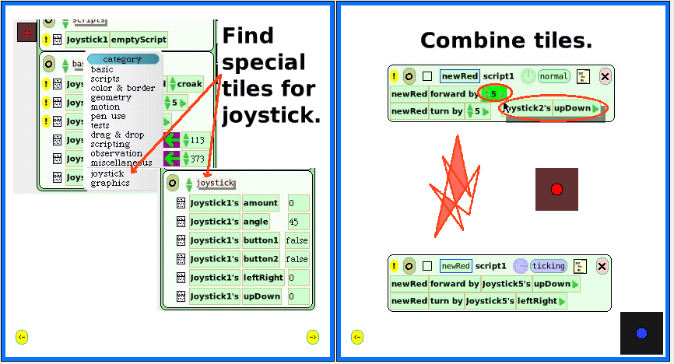
3 4
Motion Bounce

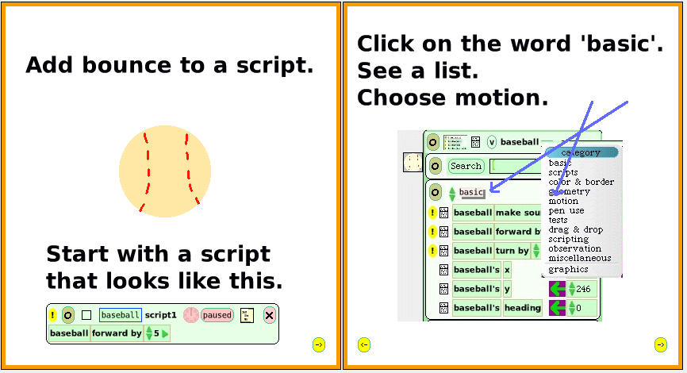
1 2

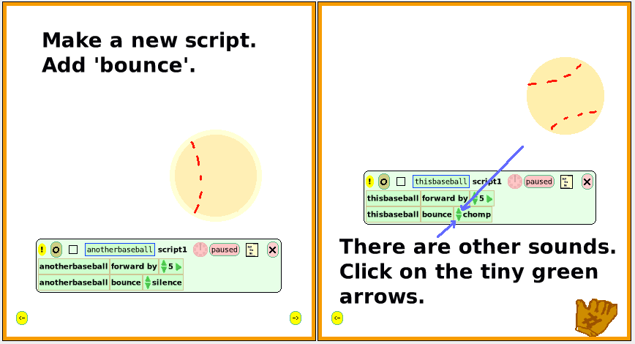
3 4

MouseStillDown in Script Run Menu

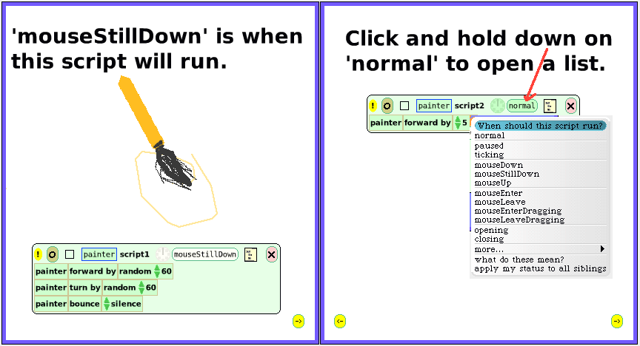
1 2

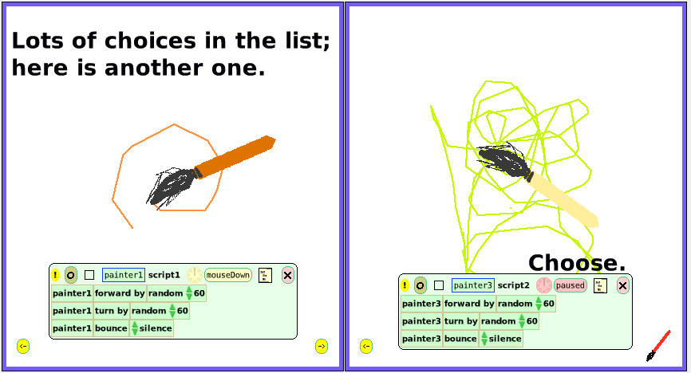
3 4

Paint Brush Sizes

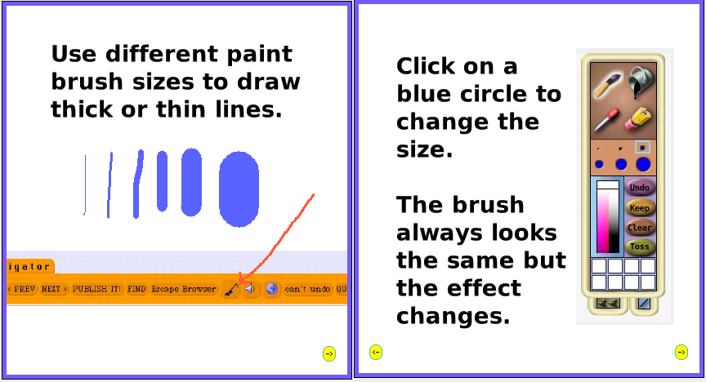
1 2

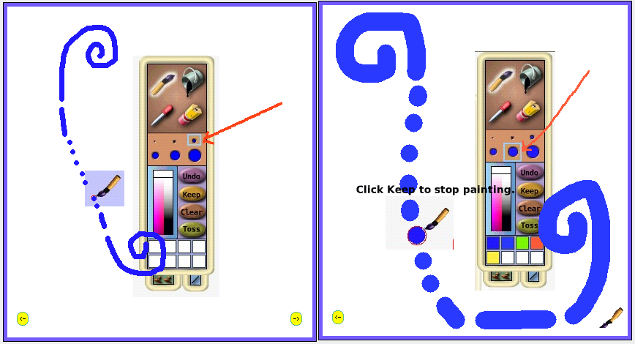
3 4
Paint Bucket Tool

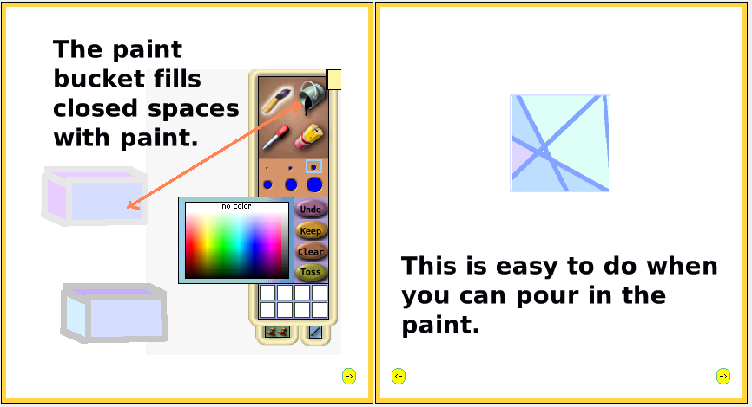
1 2

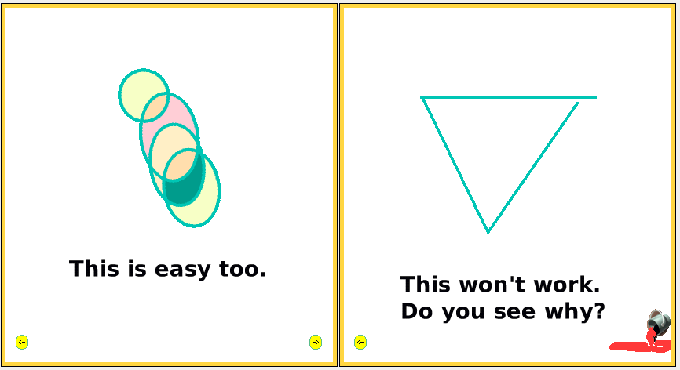
3 4

Paint Color Match Eye-dropper

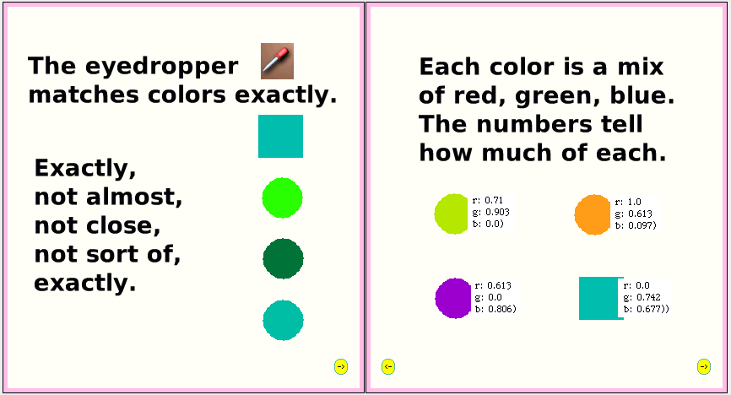
1 2

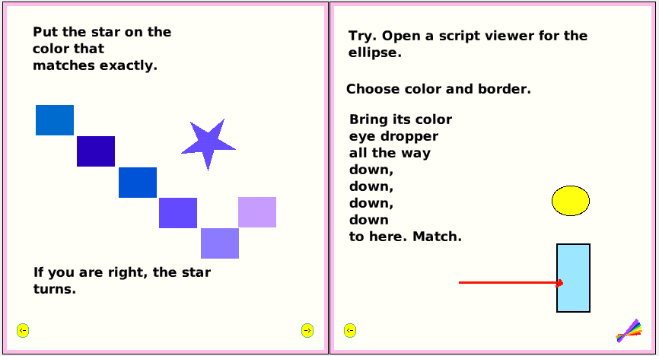
3 4

Paint Colors Palette

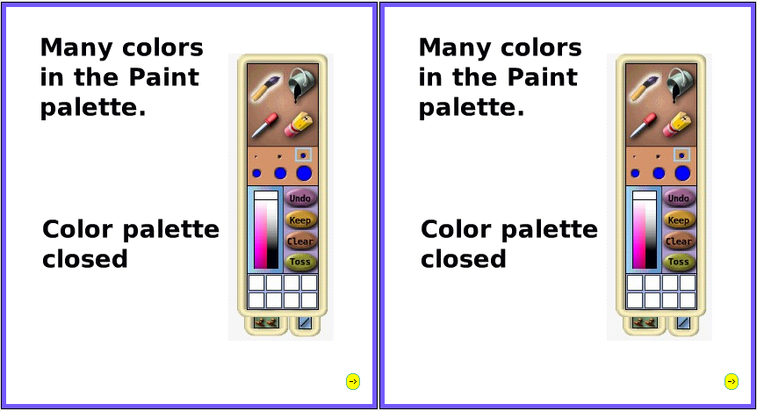
1 2

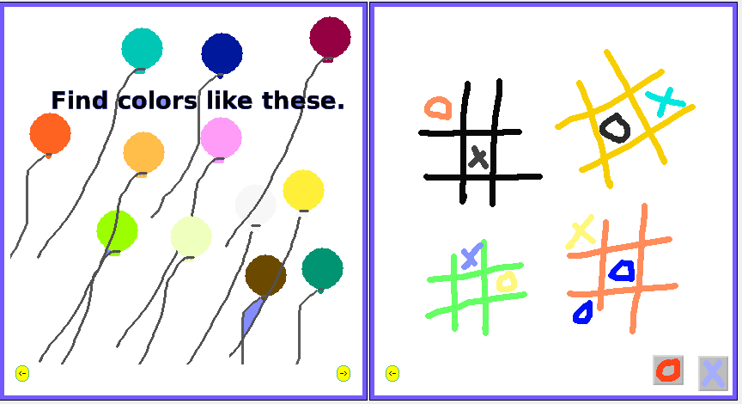
3 4

Paint Ellipse Tool

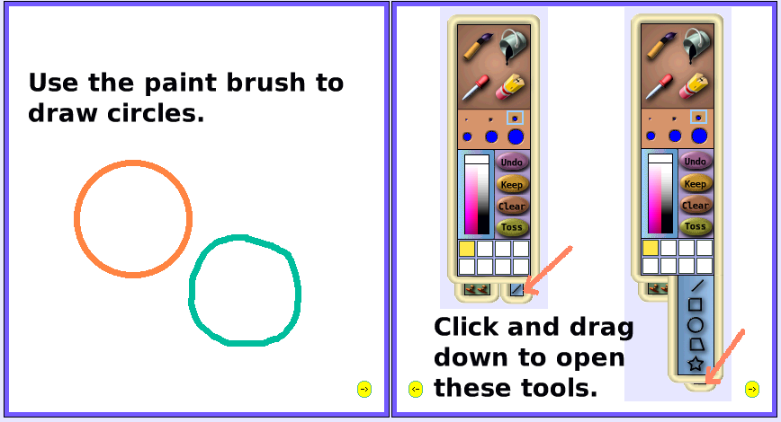
1 2

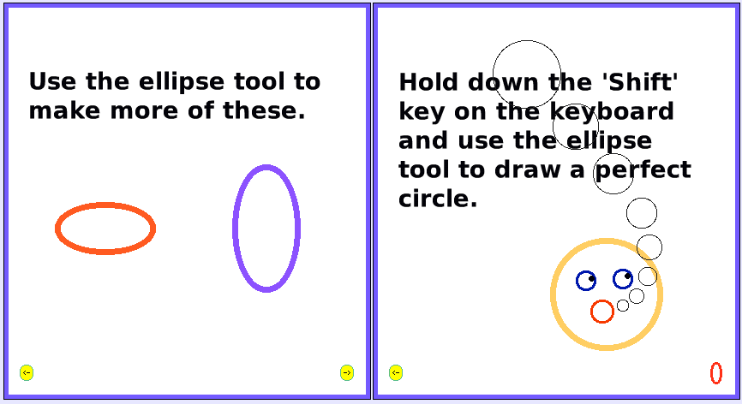
3 4

Paint Polygon Tool

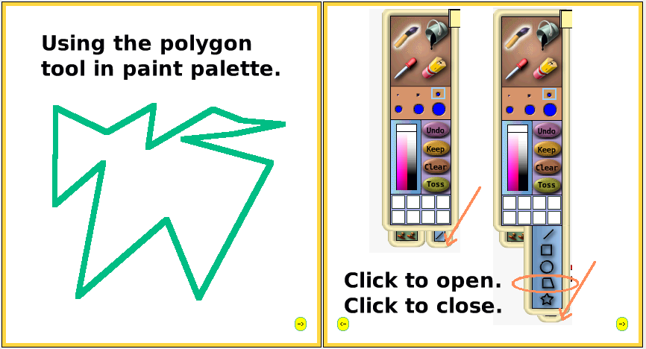
1 2

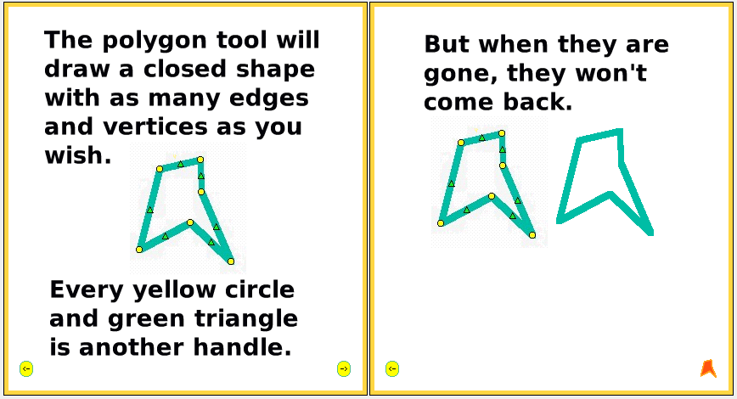
3 4

Paint Rectangle Tool

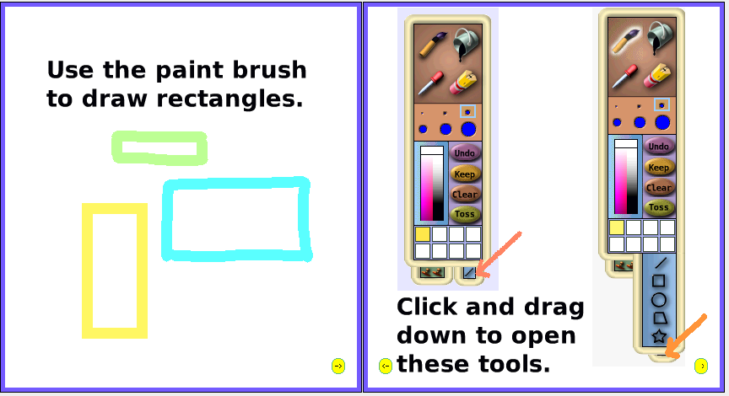
1 2

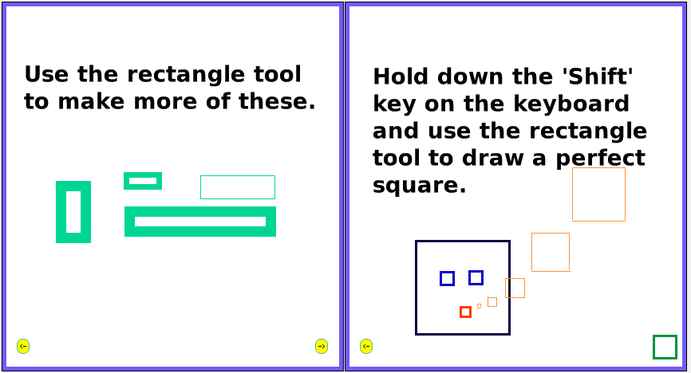
3 4
Paint Stamp Tool

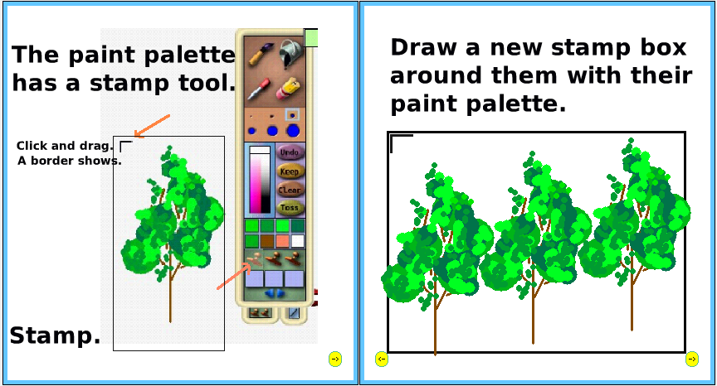
1 2

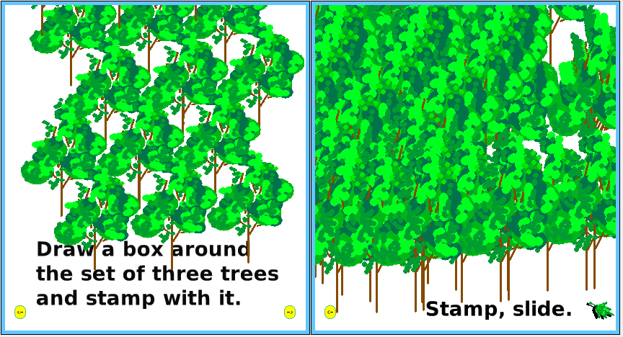
3 4

Paint Straight Line Tool

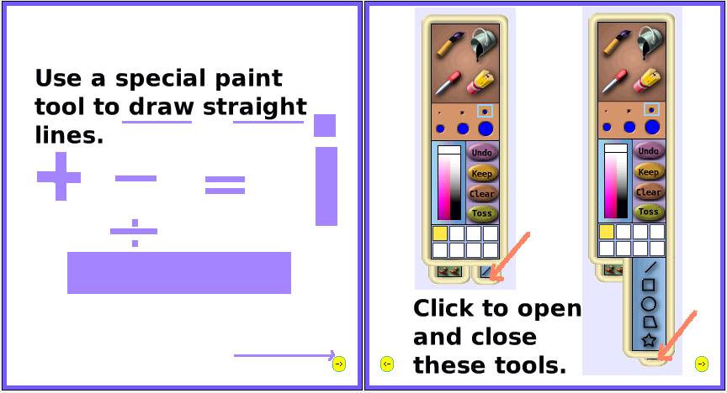
1 2

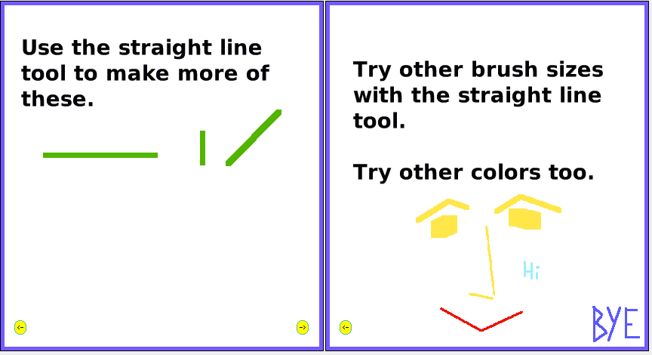
3 4

Pen Trails

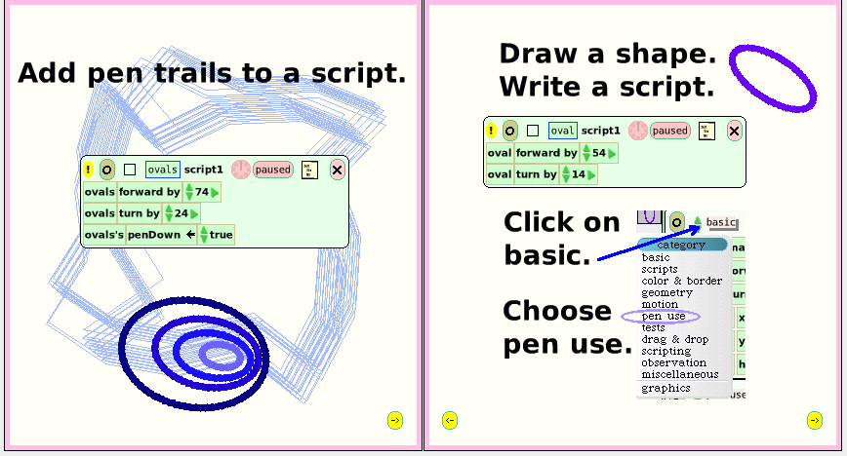
1 2

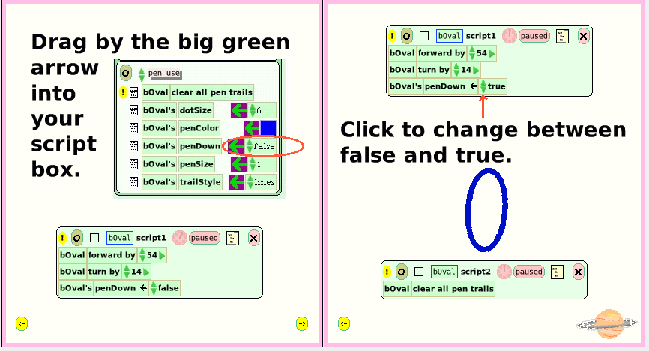
3 4

Scale Factor

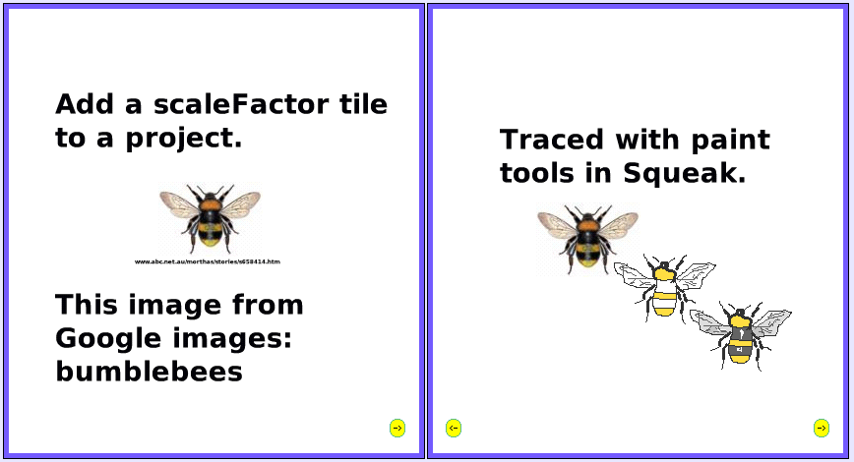
1 2

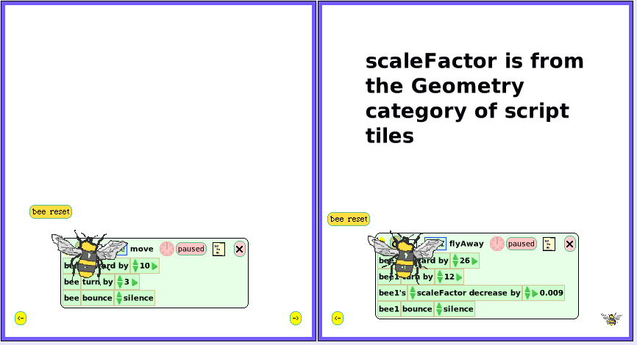
3 4
Simple and Detailed Watchers

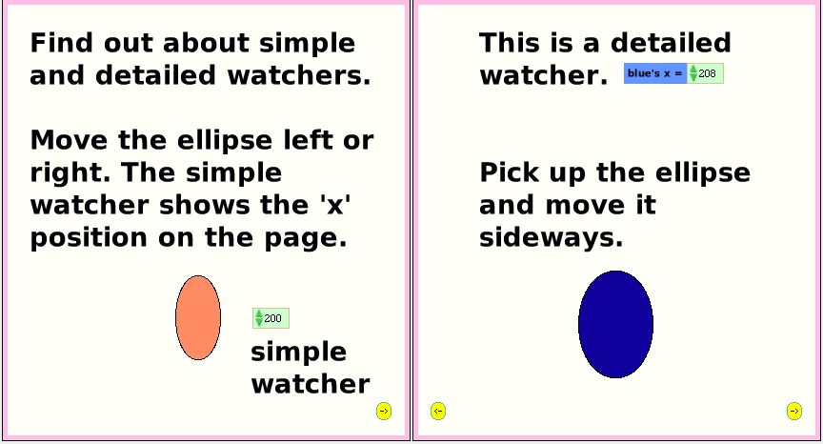
1 2

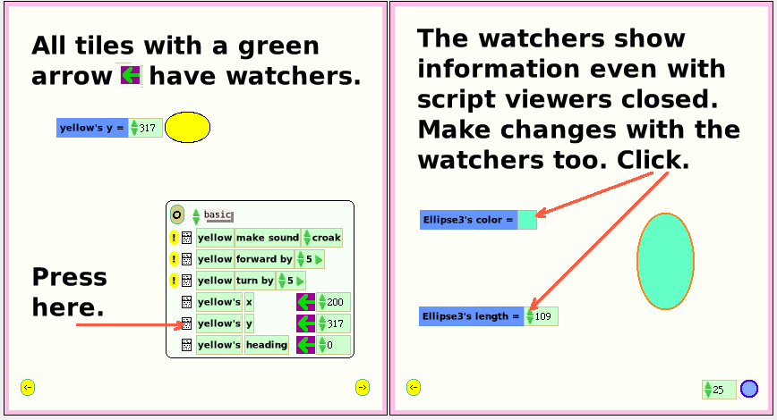
3 4
Slider Control

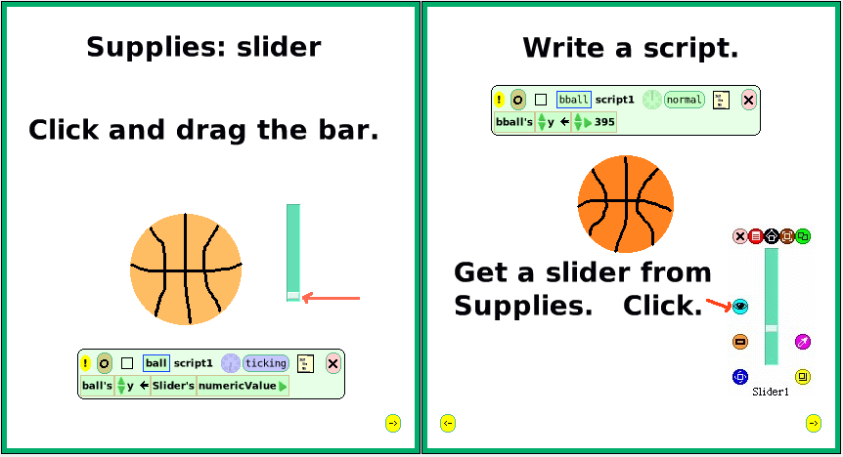
1 2

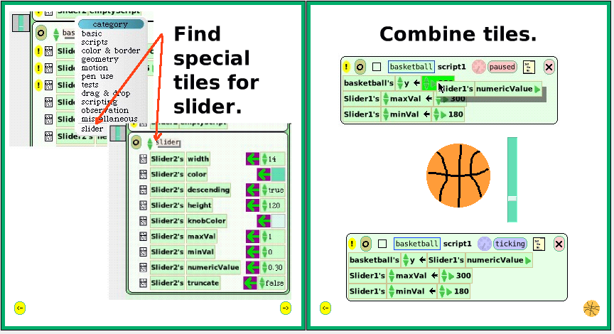
3 4

Stamp Tile

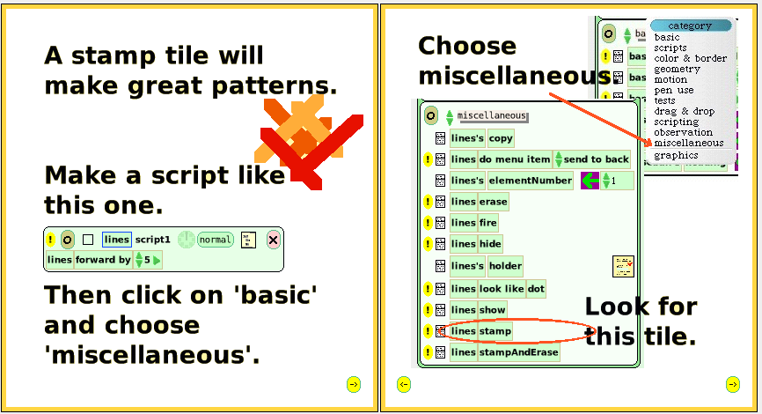
1 2

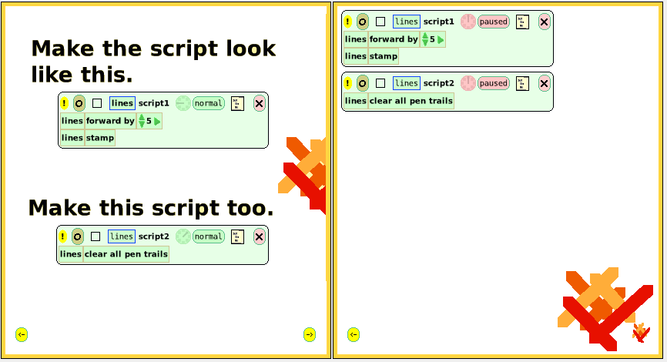
3 4

Turn By Tile

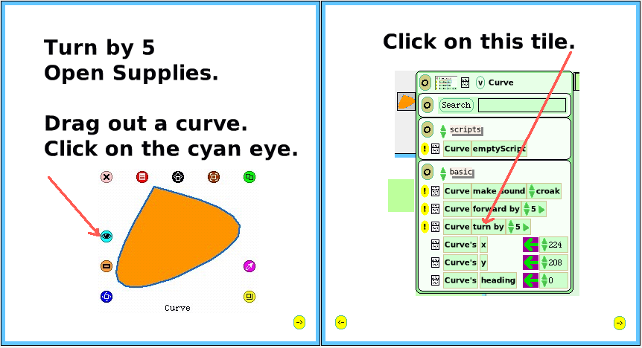
1 2

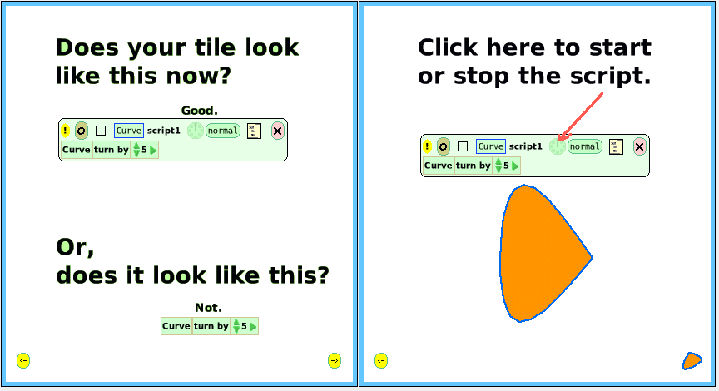
3 4

X and Y Positions

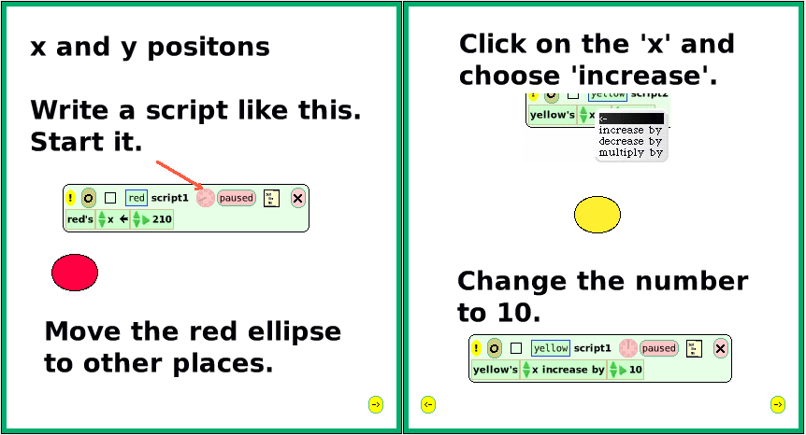
1 3

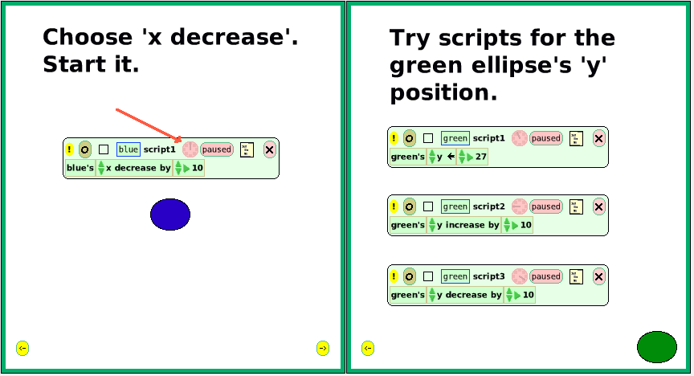
3 4

